Two Hajj Packages are available : Two weeks & Three Weeks  Departure & Return Dates: (Approx.):  - Departure date (both groups): Thursday 1st August 2019.*  - Return date (2 weeks): Friday 16 August 2019.*  - Return date (3 weeks): Thursday 22 August 2018.*  (These dates above are approximate and subject to flight confirmation.)  Madinah is our first stop. We go to Madinah first for Ziyarat.  What is included in the package?  - Accommodation: 4 people per room in Madinah and Makkah hotels.  - Air ticket.  - Transport.  - Food (half board i.e. breakfast and dinner.)  - Qurbani.  Registration requirements:  - Filling the registration form.  - Deposit of €1000.00 plus €100 non-refundable registration fee.  3) Two passport size photos.  4) Copy of passport (data page/s.)  5) Filled and Signed visa application form.  6) Copy of marriage certificate for couple travelling together.  7) Copy of Garda card (for non-EU nationals.)  8) Proof of address.  9) Letter of employment (for employed people.)  - Booking on the first come first serve basis!  - Fees: Last years’ fees €4300.00 for two (2) weeks package and €4900.00 for Three (3) weeks package respectively. This year’s fees will be announced later. Expect increases this year of €200 to €300  Hajj registration forms are available from IFI office. | ولله على النّاس حِجُّ البيت من استطاع إليه سبيلاً."  “Pilgrimage to the house is a duty which people owe to Allah – those who can find  a way to it.”  Hajj 2019 – 1440 H  Booking is being taken. Register now!  Registration forms available from IFI office.  *The Islamic Foundation of Ireland is a licensed Tour Operator in Ireland by the  Commission for Aviation Regulation. Tour Operator No. TO245.
  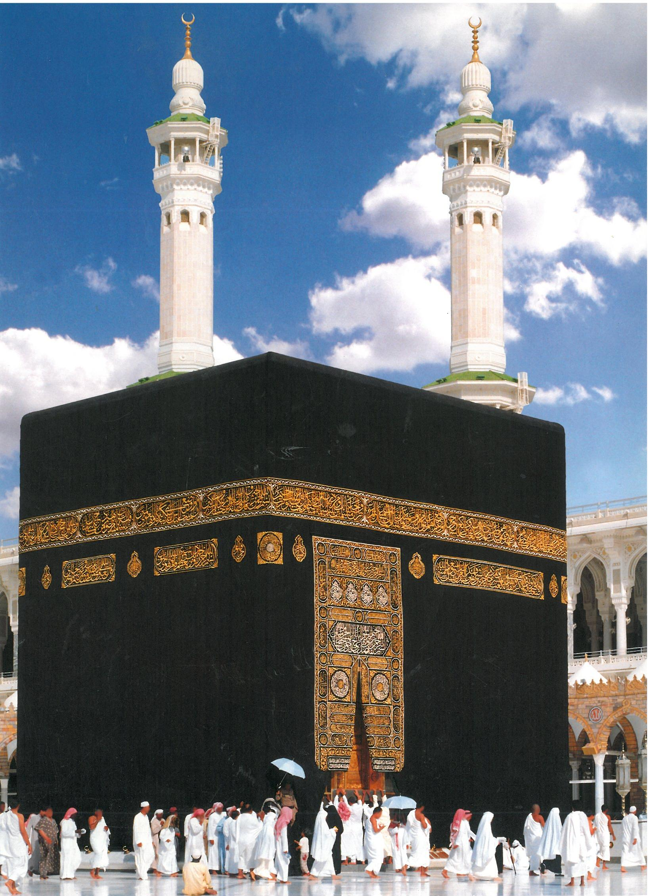 | 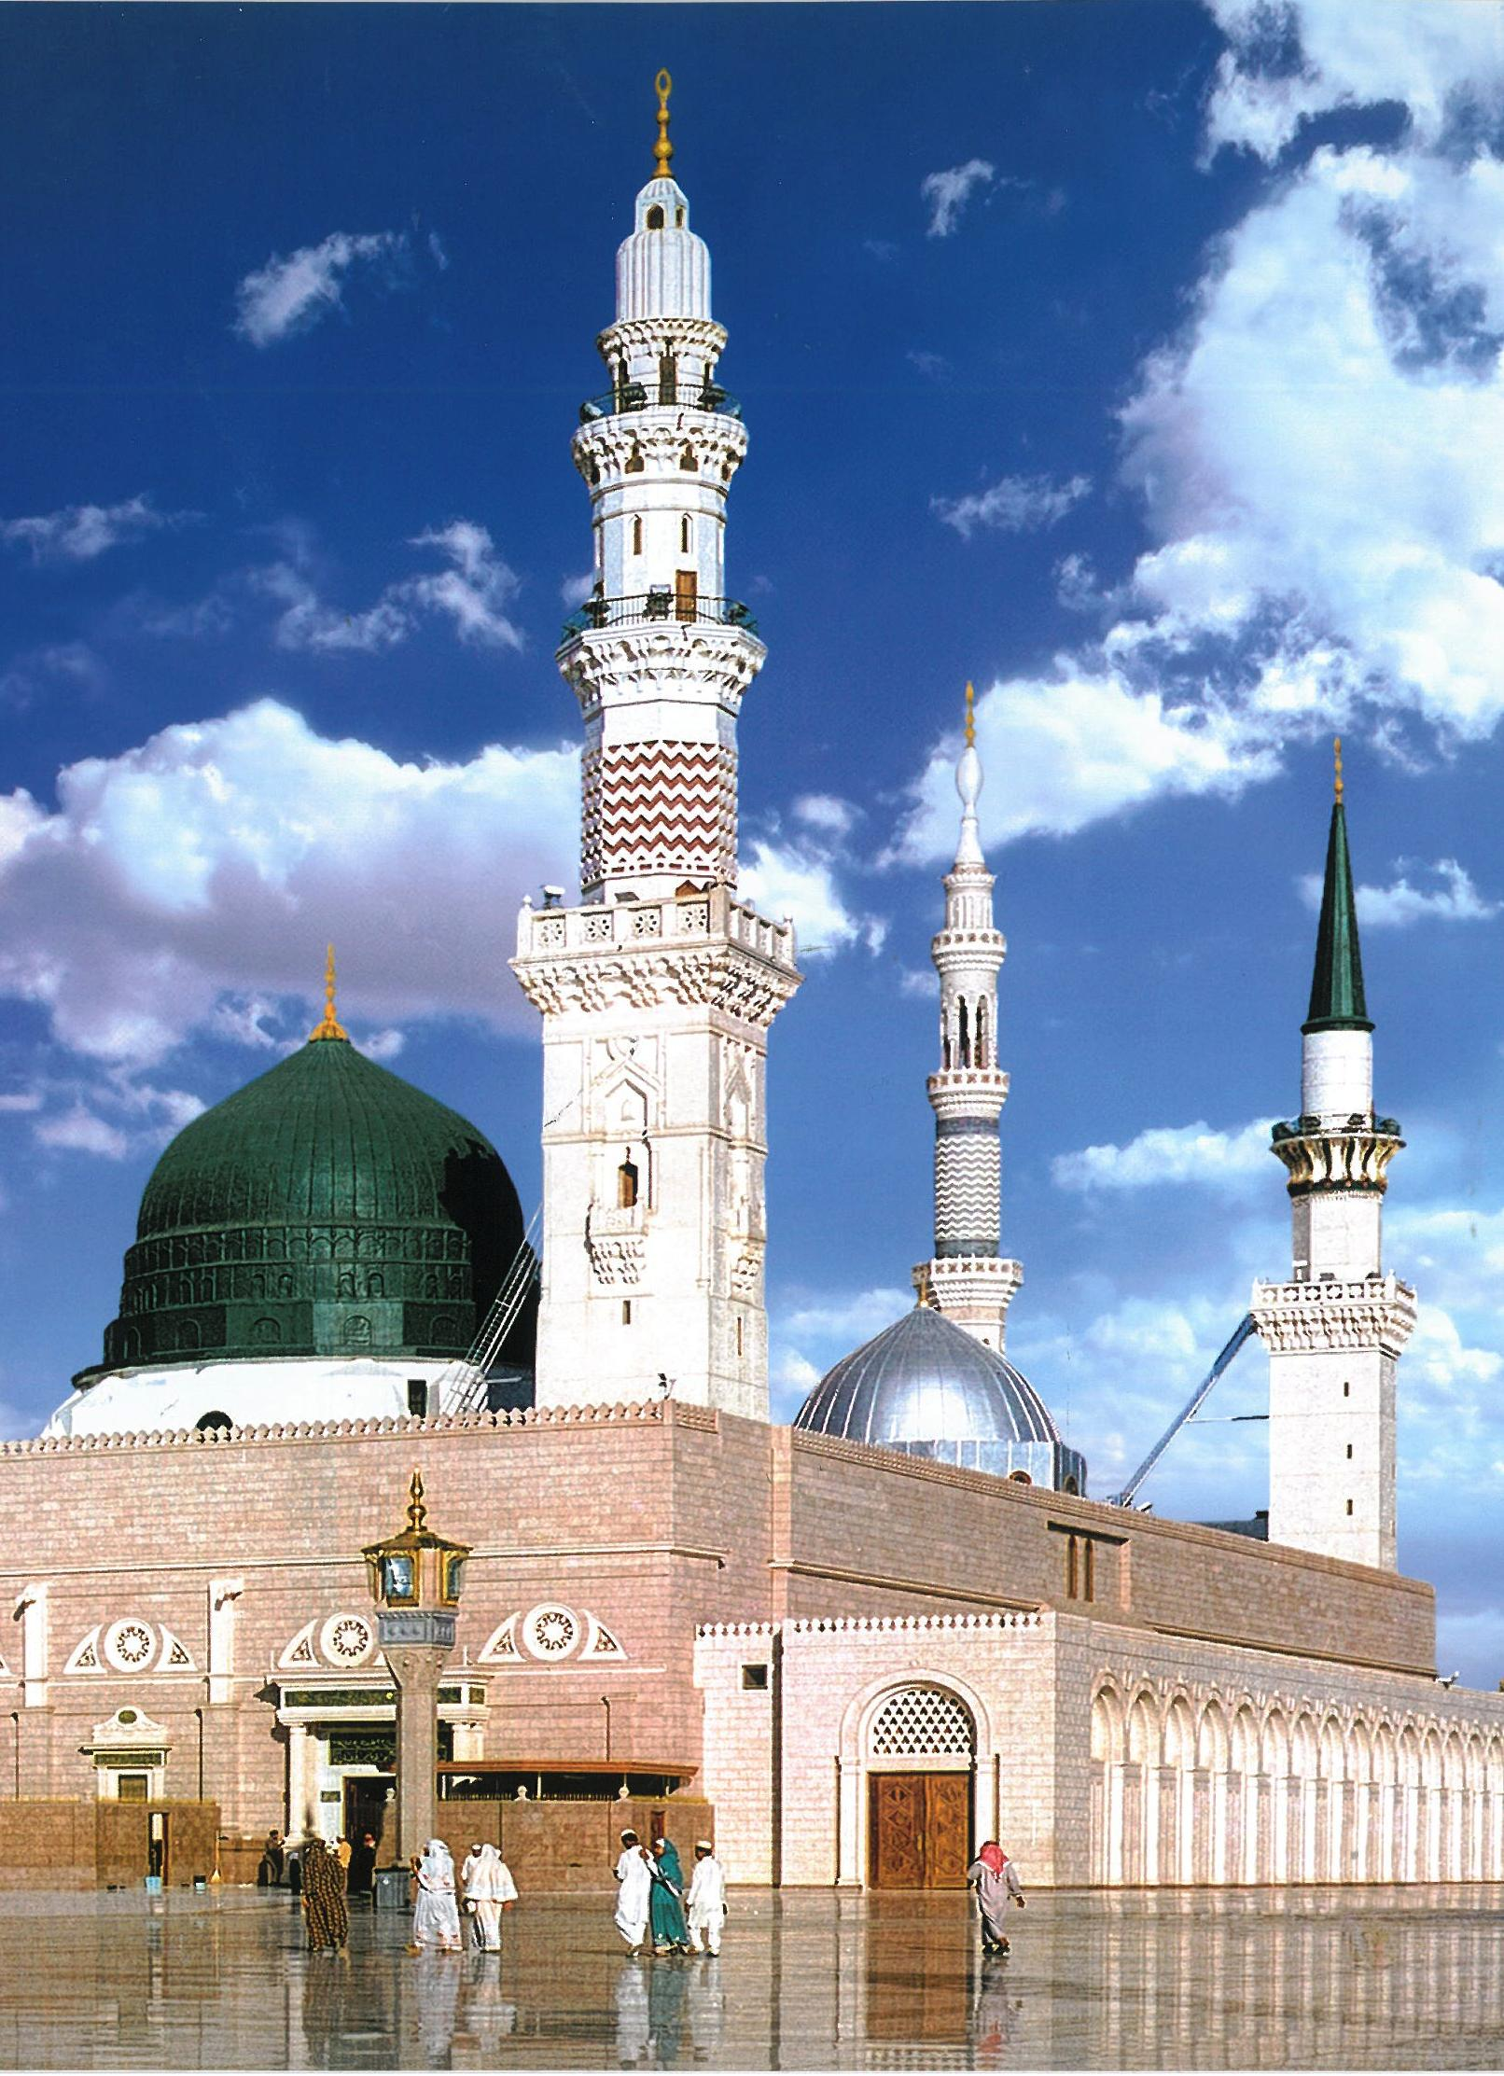
  The Islamic Foundation of Ireland  163 South Circular Road, Dublin 8.  Tel. 01-4533242.  Email: ifi@indigo.ie www.islaminireland.com | 

