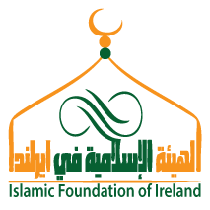
Islamic Foundation of Ireland
Friendly Society (Reg. No. 1719 S.A.) Charity (Reg. No. CHY6670)
163 SOUTH CIRCULAR ROAD, DUBLIN 8, IRELAND
TEL: (+353) 1 4533242, FAX (+353) 1 4532785, EMAIL:ifisisters@islaminireland.com

Expression of Interest in stall for Eid Celebration on Saturday 8th June 2019
I hereby express interest to sell wares, food, drink or Islamic materials as the organiser approves for my business on Eid Celebration at the Synge Street GAA Club, Crumlin Road, Dublin 12.
Name: ________________________
Phone: ________________________
Email: _________________________
No | Sales product | Sale price €
1.
2.
3.
4.
5.
6.
7.
8.

This form needs to be given to Nor Nasib in the email ifisisters@islaminireland.com / nornasib@gmail.com before Wednesday 29th May, 2019 so that we can process the form and sent approval letter.
We need to know what you are selling to promote it on the Eid Celebration page and on IFI Facebook page. The standard stalls cost €20 and Food Stalls €30 for the day, which needs to be paid to IFI by Wednesday 29th May, 2019 to Mudafar / Hanan in office.
Yours sincerely,

--------------------------------
Name:

Liability clause
IFI takes no responsibility for damages caused by or to your business at this venue.

